

NAME OF THE PROJECT

HOUSING: PRICE PREDICTION

Submitted by:

Ram Kumar

**ACKNOWLEDGMENT**

I have taken efforts in this project. However, it would not have been possible without the kind support and help of many individuals. We would like to extend my sincere thanks to SME. Khushboo Garg .

We are highly indebted to Flip Robo technology for their guidance and constant supervision as well as for providing necessary information regarding the project & also for their support in completing the project.

I thanks and appreciations also go to our colleague in developing the project and people who have willingly helped us out with their abilities.

Thanks all.

Ram kumar

.

**INTRODUCTION**

* Houses are one of the necessary need of each and every person around the globe and therefore housing and real estate.
* market is one of the markets which is one of the major contributors in the world’s economy. It is a very large market and there are various companies working in the domain.
* Data science comes as a very important tool to solve problems in the domain to help the companies increase their overall revenue, profits, improving their marketing strategies and focusing on changing trends in house sales and purchases.

* Predictive modelling, Market mix modelling, recommendation systems are some of the machine learning techniques used for achieving the business goals for housing companies.
* The company is looking at prospective properties to buy houses to enter the market. You are required to build a model using Machine Learning in order to predict the actual value of the prospective properties and decide whether to invest in them or not. For this company wants to know:

**Analytical Problem Framing**

Import library and load the dataset

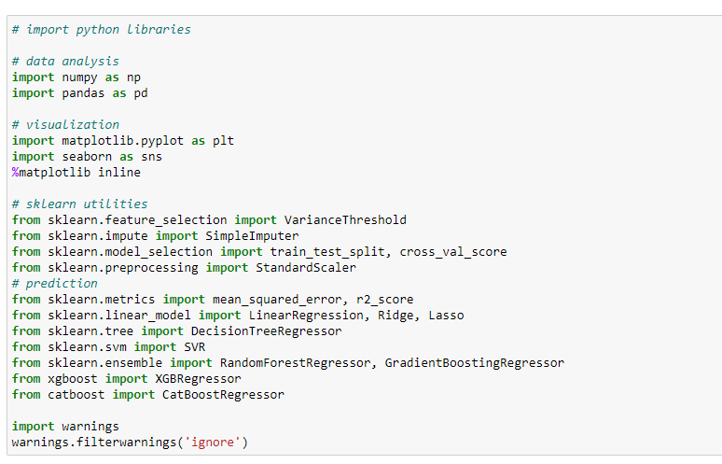

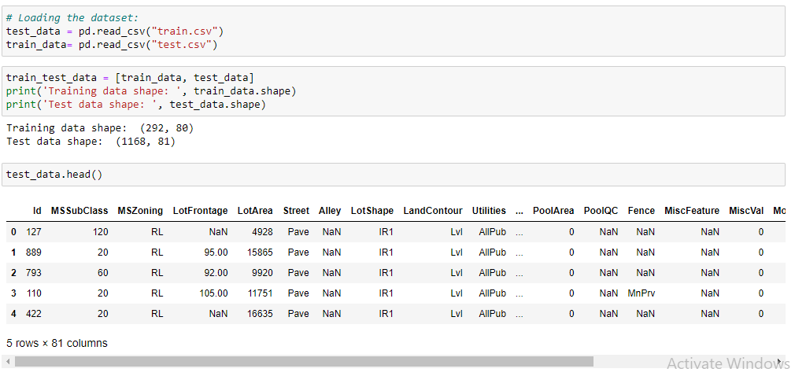

* Display all column name of dataset.

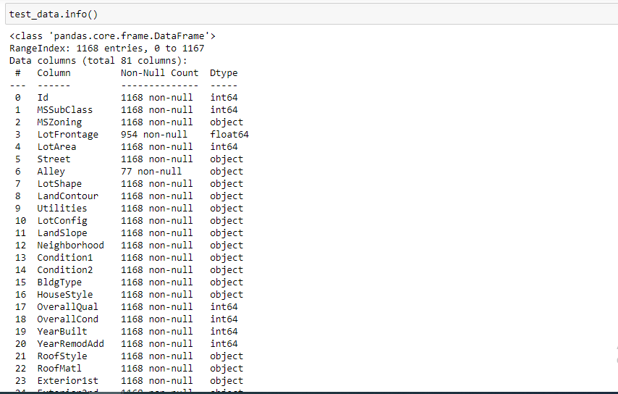

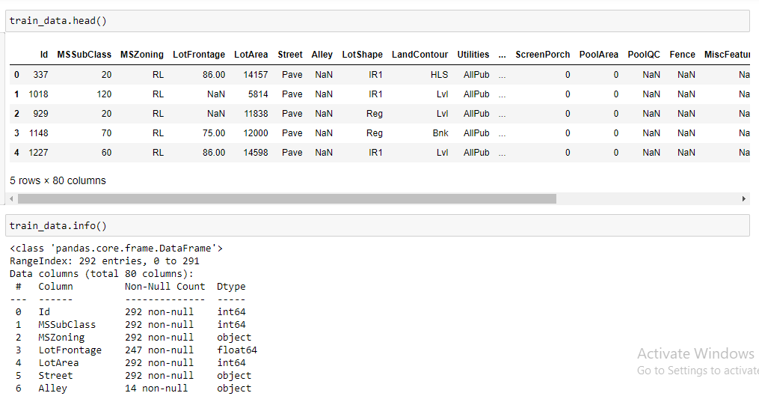

* Display statistical summary.

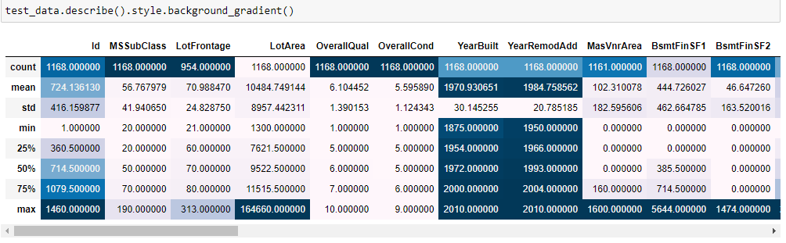

* Display barplot of all columns.

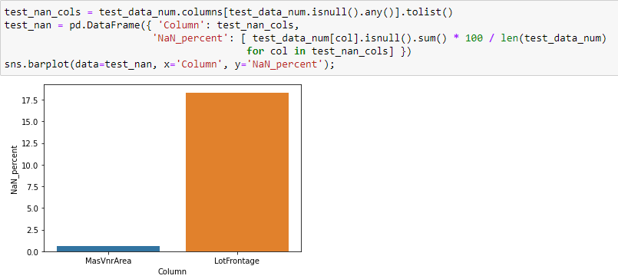

* Display correlation of columns using heatmap.

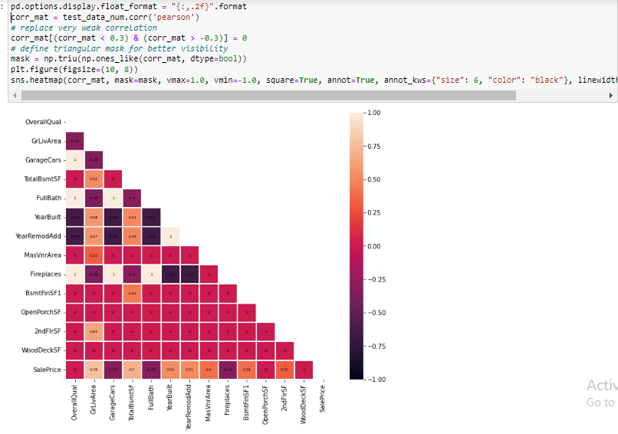

* Display barplot of all columns.

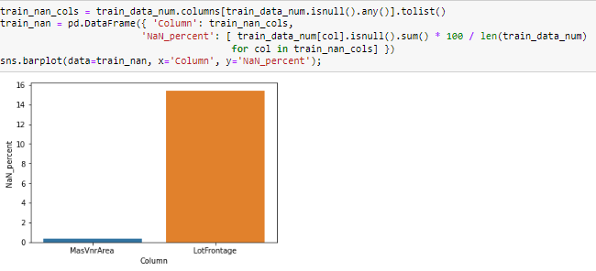

* Display outliers of all columns.
* 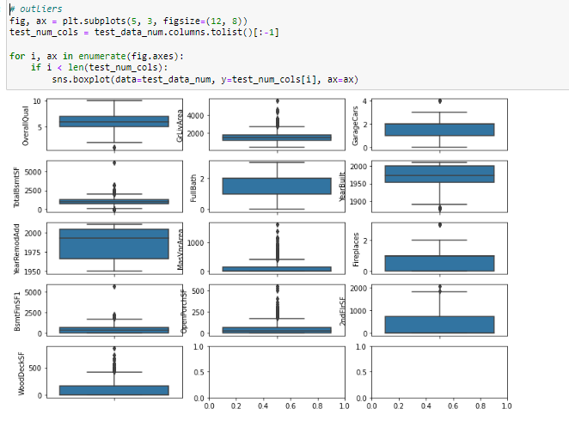
* filling empty values.

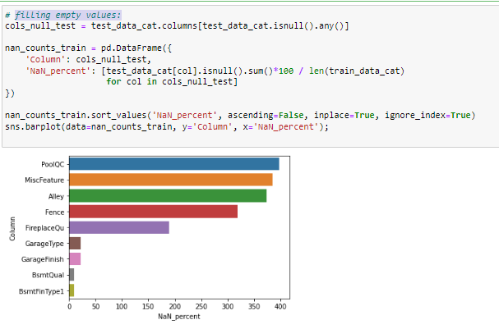

**Model/s Development and Evaluation**

* **Feature engeenering:**

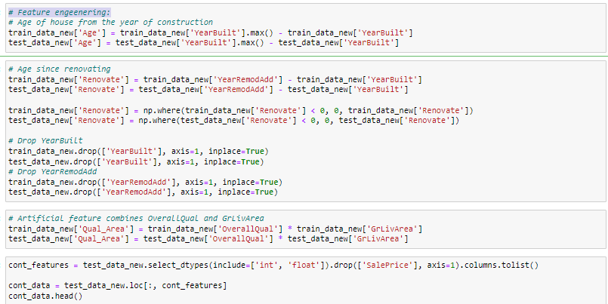

* Testing of Identified Approaches (Algorithms)

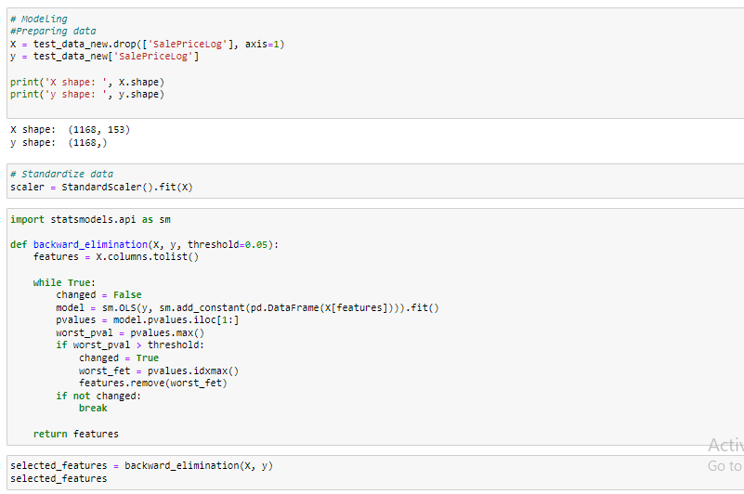

* Run and Evaluate selected models

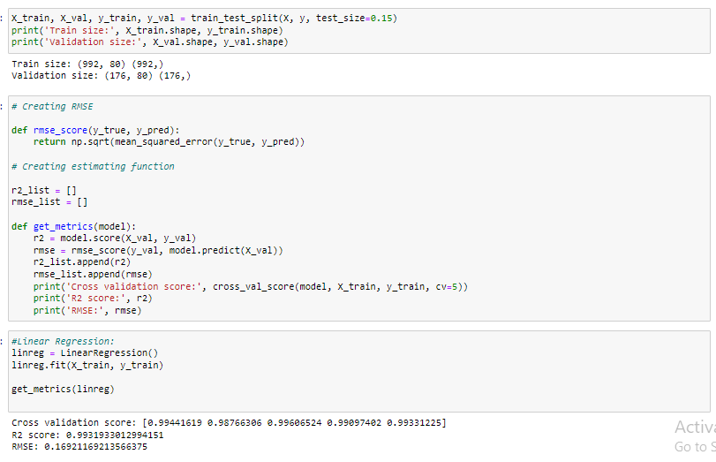

* Creating RMSE:

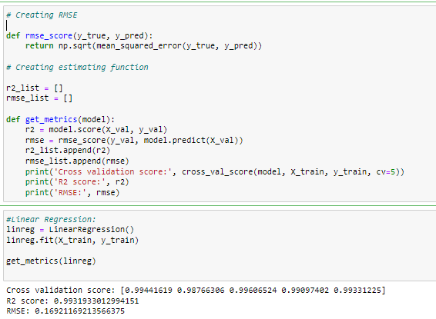

* Decision Tree:

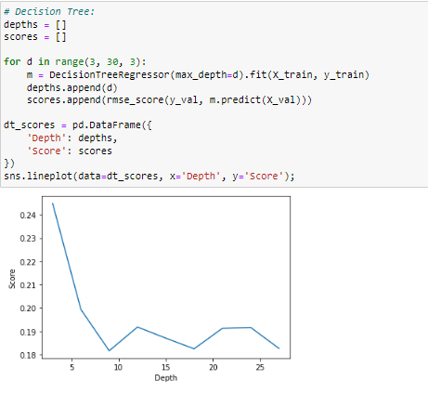

* Interpretation of the Results

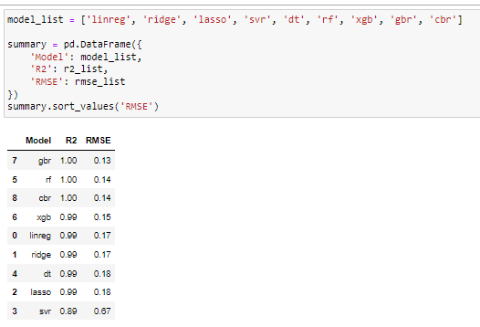

* **Prediction of dataset:**

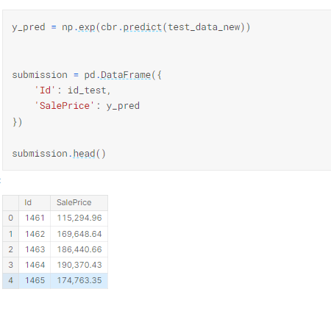

* Hardware and Software Requirements and Tools Used
* **Language :-** Python
* **Tool:-** Jupyter
* **OS:-** Windows 10
* **RAM:-** 8gb

**CONCLUSION**

This Kernel investigates different models for housing price prediction. Different types of Machine Learning methods including CatBoostRegressor, GradientBoostingRegressor and LightGBM and two techniques in machine learning are compared and analyzed for optimal solutions. Eventhough all of those methods achieved desirable results, different models have their own pros and cons.

The GradientBoostingRegressor is probably the best one and has been selected for this problem. The BayesianOptimization method is simple but performsa lot better than the three other availabel methods due to the generalization.

Finally, the CatBoostRegressor is the best choice when parametrerization is the top priority.